Book Launch:

Freedom Sailors
In August 2008, the Free Gaza Movement sent the first international boats to land in the port of Gaza in 41 years to break the illegal siege
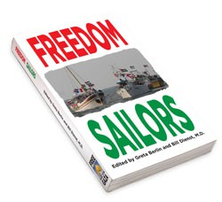
Freedom Sailors tells the story of 44 passengers on two dilapidated boats that sailed to Gaza in August 2008 and breached Israel's illegal blockade. Hear co-editor Greta K. Berlin launch Freedom Sailors in Toronto, and learn more about the Canadian Boat to Gaza’s new project, Gaza’s Ark.
September 28, 2012 - Event 3pm
at Cordoba House (88 Forsyth N., Hamilton,
Across from McMaster University
Free Admission – Donations Accepted. All proceeds to go to Gaza's Ark
Greta K. Berlin is a media communications expert, and a spokesperson and cofounder of the Free Gaza Movement. She was on board the FREE GAZA – the first boat with internationals to reach the besieged strip of the Mediterranean in 41 years. She has been an advocate for justice for Palestinians since the early 1960s and she has worked for the International Solidarity Movement in the West Bank.
What people are saying about Freedom Sailors:
“A riveting account of one of the great moments in the history of non-violent resistance: breaking the criminal and sadistic siege of Gaza, and letting the prisoners know that at least some of the outside world care about them and their grim fate. The Free Gaza flotillas are truly an inspiration.” – Noam Chomsky, Ph.D. – MIT

Parking at McMaster: $6.00. Parking in nearby streets is restricted to maximum of one hour.
Several HSR buses from downtown stop right beside Cordoba House: 1A King, 5C West Hamilton, and 51 University

Web: www.gazaark.org, www.freedomsailors.com email: hcsw@cogeco.ca

